JFlex - The Fast Scanner Generator for Java.

*Installing JFlex on Windows 7:*

1. *Go to [JFlex website](http://jflex.de/download.html" \t "_blank).*
2. *Download the jflex-X.X.X.zip if you used Windows or jflex-X.X.X.zip.gz if you use Linux . we currently download the "jflex-1.4.3.zip".*

|  |
| --- |
| [http://2.bp.blogspot.com/-wEBuY_BLvAQ/UWlqRYEvTbI/AAAAAAAAACo/bYUB2bqRmY8/s640/Untitled.png](http://2.bp.blogspot.com/-wEBuY_BLvAQ/UWlqRYEvTbI/AAAAAAAAACo/bYUB2bqRmY8/s1600/Untitled.png) |
| JFlex  download page |

1. *for windows you need to do the following steps:*

* 1. *download and extract the zip.*
  2. *go to a specific partition like c:/ or d:/ .*
  3. *you can see Jflex and jflex-1.4.3  directories, copy anyone, let's we take the "jflex".*[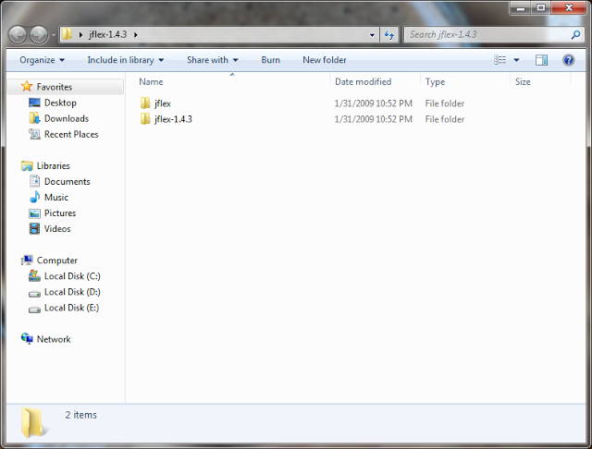](http://1.bp.blogspot.com/-IDDZVb9Mj_U/UWltF_CuFEI/AAAAAAAAAC4/5p-bBhkdSww/s1600/2.png)

* 1. *now copy and past the extracted file to any partition (let we take  c:/ partition ).*
  2. *the structure of the extracted file should be*
  3. C:\JFlex\
  4. +--bin\ (start scripts)
  5. +--doc\ (FAQ and manual)
  6. +--examples\
  7. +--binary\ (scanning binary files)
  8. +--byaccj\ (calculator example for BYacc/J)
  9. +--cup\ (calculator example for cup)
  10. +--interpreter\ (interpreter example for cup)
  11. +--java\ (Java lexer specification)
  12. +--simple\ (example scanner)
  13. +--simple-maven\ (example with maven)
  14. +--standalone\ (a simple standalone scanner)
  15. +--standalone-maven\ (above with maven)
  16. +--lib\ (the precompiled classes)
  17. +--src\
  18. +--JFlex\ (source code of JFlex)
  19. +--JFlex\gui (source code of JFlex UI classes)

+--java\_cup\runtime\ (source code of cup runtime classes)

* 1. *now the file should be placed like the following figure:*[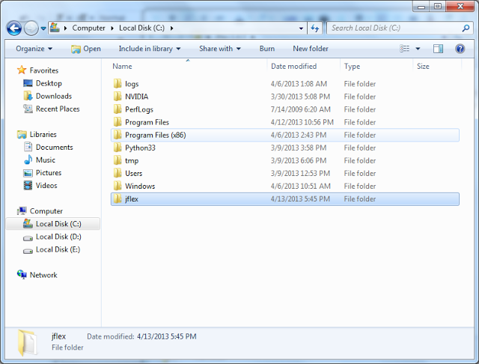](http://1.bp.blogspot.com/-v7OJX5iqhFI/UWlvvtNB80I/AAAAAAAAADA/_vVaOFxSRv8/s1600/3.png)
  2. *Installing System variables:****JFlex depends on JDK,****that's mean you need to installing the JDK from*[*Oracle site*](http://www.oracle.com/technetwork/java/javase/downloads/index.html)*.*
     1. *after downloading and installing the JDK "****J****ava****D****evelopment****T****oolkit", you need to make sure about the "PATH" for JDK, actually if you placed a JDK path in System path, you can used the JDK from the "cmd" directly and allowed to run any java application on windows platform (i.e. launch the JRE "Java Runtime environment" on windows).*[*more info.*](http://msdn.microsoft.com/en-us/library/windows/desktop/ms682653(v=vs.85).aspx)
     2. *go to "start menu" and right click on* *"computer" and select "properties".*[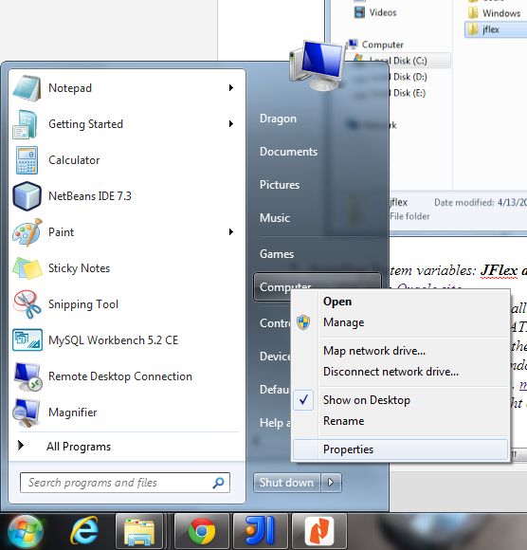](http://3.bp.blogspot.com/-KI3Gllk7-ZA/UWlzuum5LMI/AAAAAAAAADM/d7BZrFyeS04/s1600/4.png)
     3. *now you see the properties window, select the "Advanced System Setting" and from the "System Properties" window select the "Environment  Variables".*[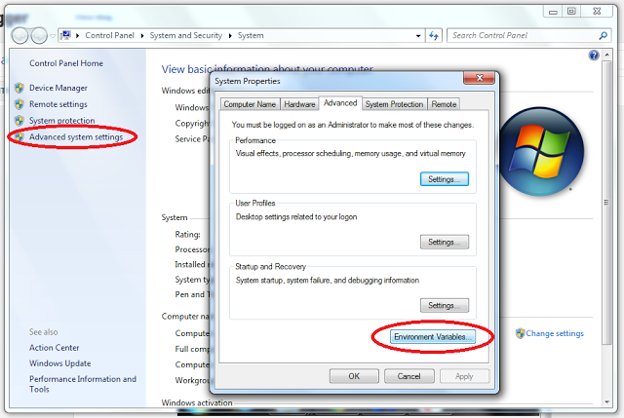](http://2.bp.blogspot.com/--Oo019I9K4I/UWl01saDEDI/AAAAAAAAADY/15KLZr-x5zo/s1600/5.png)
     4. *form the "Environment  Variables" window, go to "System variables" group, and find the PATH  variable, double click on the PATH variable, now you can see the "Edit System Variables" input box. you need to specify the path of JFlex and JDK like "c:/jflex/bin" [don't miss the semi colon ( ; ) ], and for the JDK you need to check if is exist in the PATH variable or not (e.g. C:\Program Files\Java\jdk1.7.0\_17\bin).*[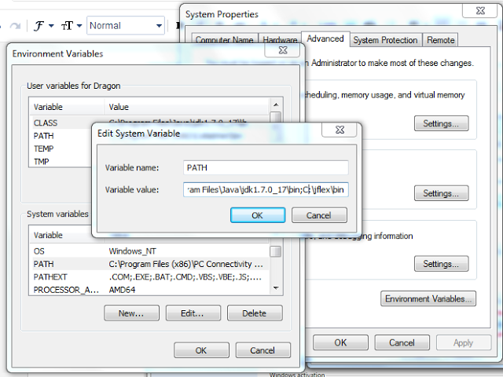](http://4.bp.blogspot.com/-gWtf9qK1Ugg/UWl3UA-9x6I/AAAAAAAAADk/uknZqDQ6-vI/s1600/6.png)
     5. *now Click on OK, OK, OK.*
     6. *finally, you need to edit the C:\jflex\bin\jflex.bat  to be:*[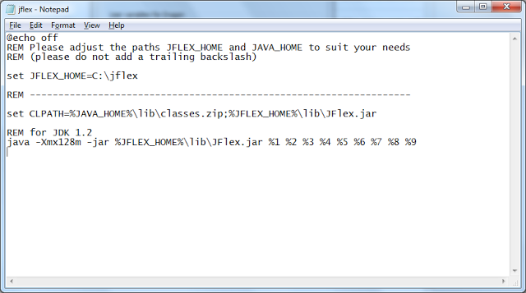](http://3.bp.blogspot.com/-vAKhiHGcHjY/UWl5zzTHVFI/AAAAAAAAADo/6mItBpnYDoo/s1600/8.png)

1. now open the "cmd" and type "jflex" then press Enter,

**Running Jflex**

* 1. 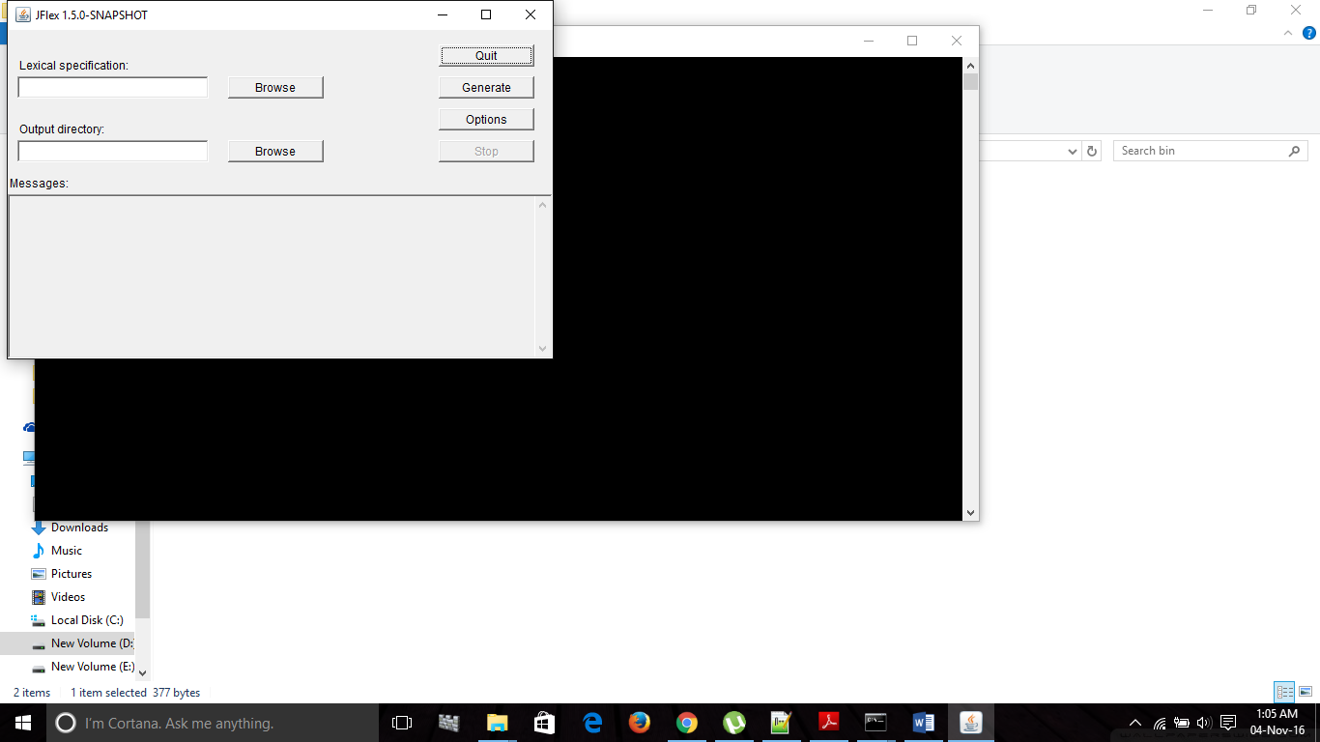Double click on jflex.bat file. A window will appear like the following figure.

2. Now click on the “Browse” button under Lexical Specification and select the flex file (example.flex)

3. You can specify the Output directory where the “.java” file will be created. Then click on “Generate” button. A message “Generation finished successfully” will appear if there is no error in the flex file like the following figure.

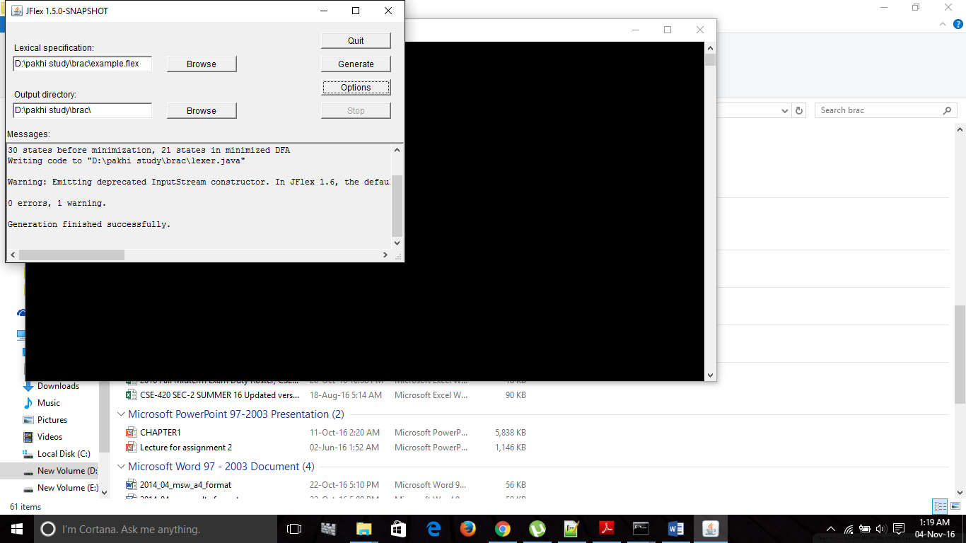

4. After that you will have to run the java file from command line. First compile the java file and then run the file.

